Lab Report-2
1.Write a C/C++ program that implements Magic Square, Stack, and Queue.
Objectives:
- To create a Magic Square using a C/C++ program.
- To implement a Stack using an array.
- To perform basic Stack operations like push, pop, and display.
- To implement a Queue and perform operations like enqueue, dequeue, and display.
Magic Square:
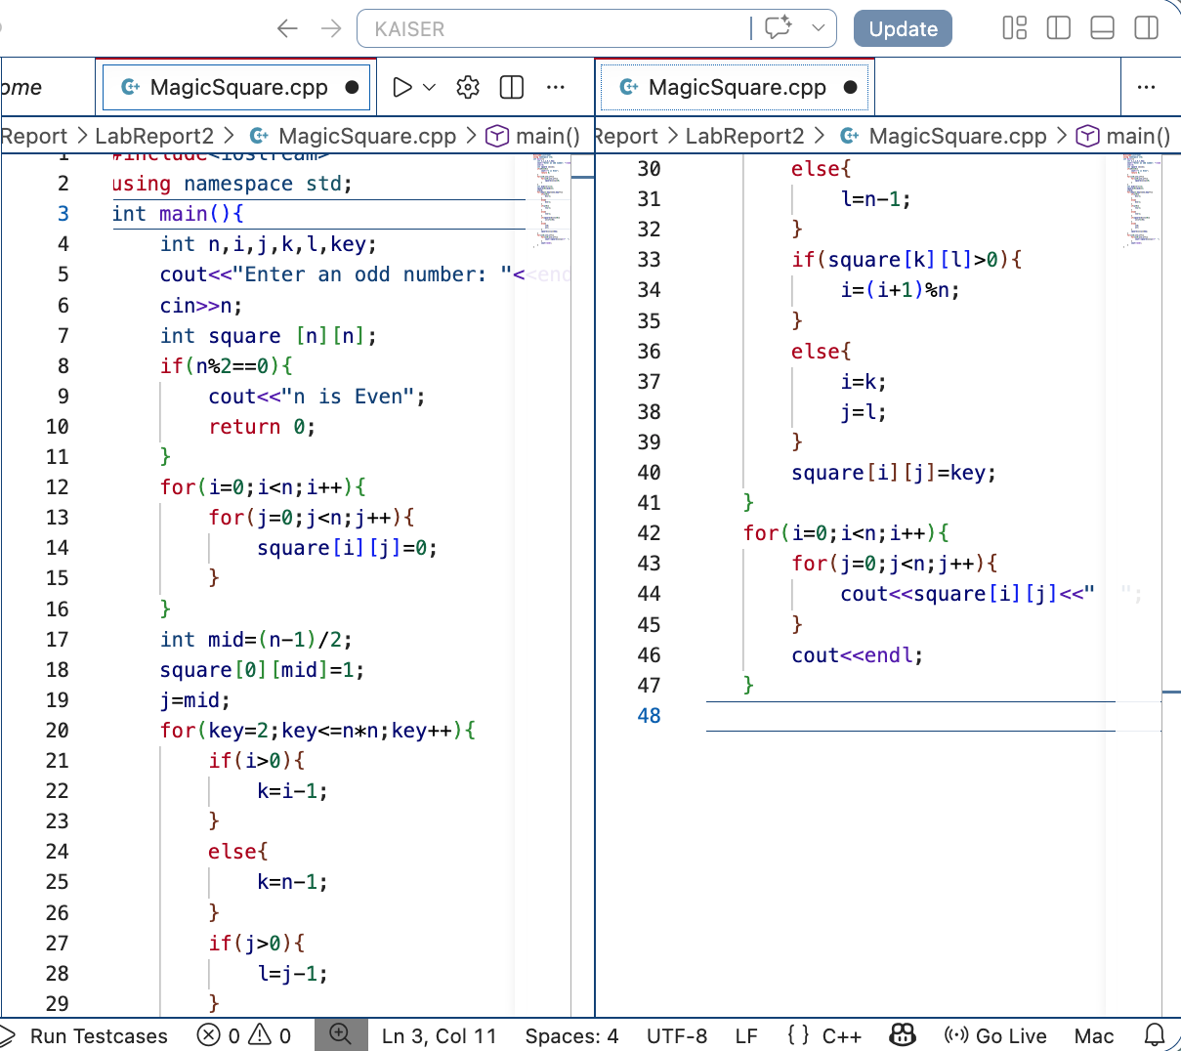
Source code: Input & Output: 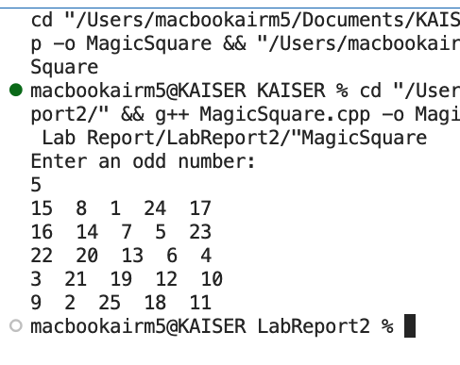

Stack:
Source code: Input & Output:
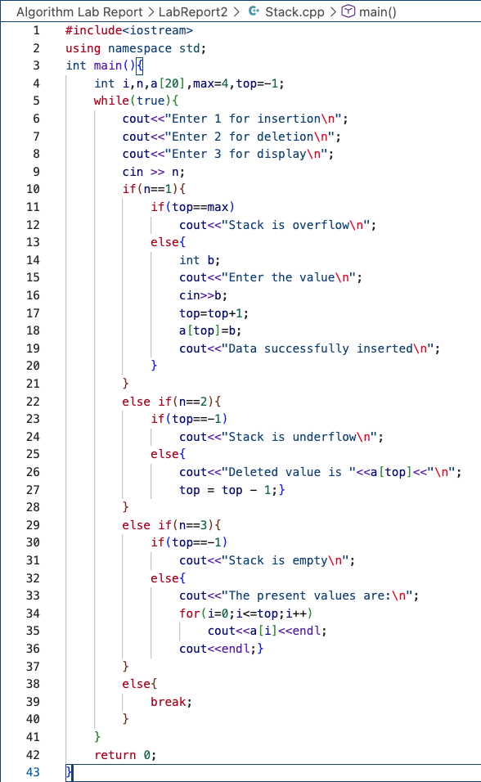
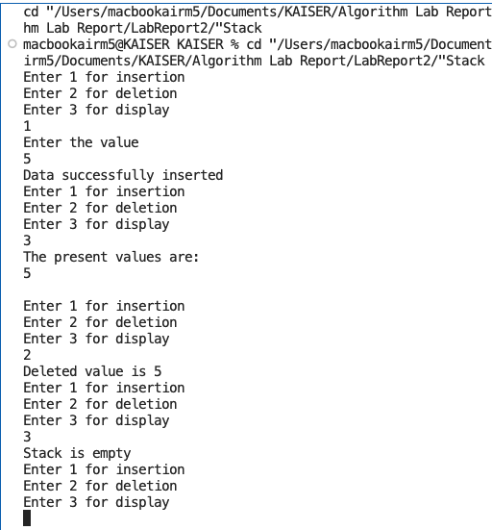

Queue:
Source code: Input&Output:
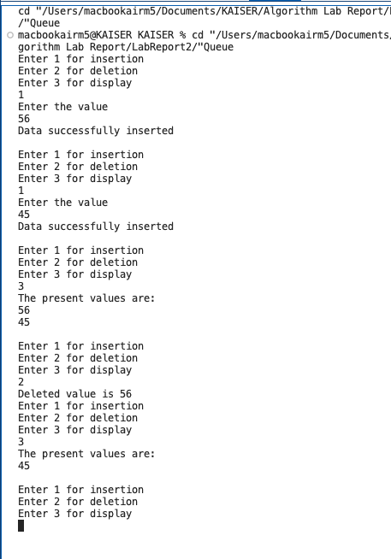
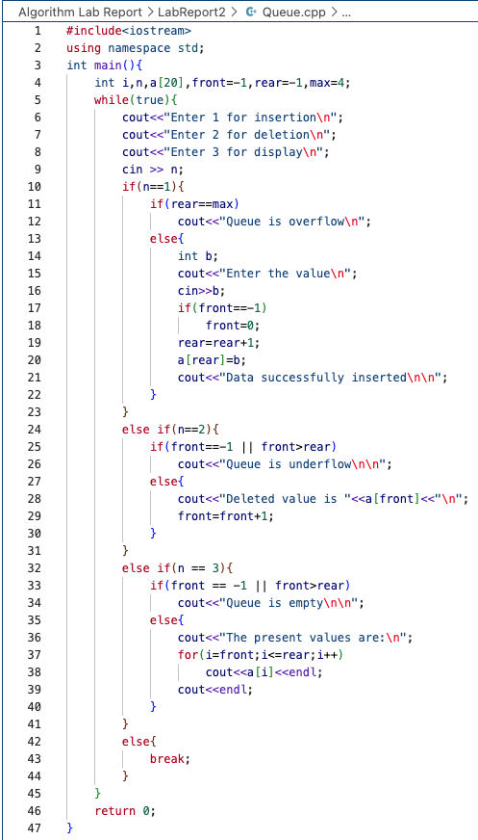

Conclusion:
In this experiment, a Magic Square was successfully generated using a C/C++ program. The logical arrangement and pattern of numbers were clearly understood through this implementation. A Stack was also implemented using an array, and its basic operations such as push, pop, and display were performed successfully. Similarly, a Queue was implemented, and operations like enqueue, dequeue, and display were carried out. Through these programs, the concepts of basic data structures and their operations were clearly understood, and programming skills were improved.

